NATIONAL COLLEGE OF COMPUTER STUDIES (NCCS)

**Tribhuvan University**

**Institute of Science and Technology**

**SEARCHING MY TUTOR**

**A PROJECT REPORT**

**Submitted to**

***Department of Computer Science and Information Technology***

***National College of Computer Studies***

***NCCS lai submit garne haina TU ko IOST lai subbmit garne ho***

***In partial fulfillment of the requirement for the Bachelor Degree in Computer***

***Science and Information Technology***

**Submitted by**

Ankit Agarwal [S.N. 1309/068]

Ranjan Khadka [S.N. 1322/068]

Subin Tiwari [S.N. 1328/068]

August 2015

**National College of Computer Studies**

**Tribhuvan University**

**LETTER OF APPROVAL**

This is to certify that this project prepared by Ankit Agarwal [1309/068], Ranjan Khadka [1322/068] and Subin Tiwari [1328/068] entitled “Searching My Tutor” in partial fulfillment of the requirements for the degree of B.Sc. in Computer Science and Information Technology has been well studied. In our opinion it is satisfactory in the scope and quality as a project for the required degree.

|  |  |
| --- | --- |
| **SIGNATURE** | **SIGNATURE** |
| **SIGNATURE** | **SIGNATURE** |

**National College of Computer Studies**

**Tribhuvan University**

**Supervisor’s Recommendation**

I hereby recommend that this project prepared under my supervision by Ankit Agarwal [1309/068], Ranjan Khadka [1322/068] and Subin Tiwari [1328/068] entitled “Searching My Tutor” in partial fulfillment of the requirements for the degree of B.Sc. in Computer Science and Information Technology be processed for the evaluation.

**SIGNATURE**

**SUPERVISOR**

**ABSTRACT**

The ***report project work vanne*** deals with the use of information technology that helps a teacher to search for a home tuition and a student to search for a tutor. The project is entitled “Searching My Tutor”. SMT is a web based application supporting these facilities. The application is developed with simple user-interfaces but giving high priority to the application logic. The application logic uses the Artificial Neural Network- Back Propagation Algorithm (ANN BP) to search for perfect student-teacher pair. The system also provide the users with the details of who has viewed their information like email address, contact number, address etc.

This project also aims to contribute on social welfare so that the students who are willing to teach can utilize their time and skill by searching a home tuition easily as well as the teachers who are willing to take on a home tuition can also search for a student in real time. This approach of searching by usage of machine learning stood as a successful experiment which concludes that machine learning algorithms can optimize the search where different entities have different nature of attributes. At the same time the results generated by the ANN BP algorithm can be prioritize to support recommendation.

***The front end is furnished with HTML, CSS and javascript. The application logic is realized with PHP script and back end with My SQL. Abstract maa technology kura narkaahda raamro hola just describe on our project work*** The notification based security of user information, Machine Learning and two-way searching makes this application a useful entity.

**ACKNOWLEDGEMENT**

We would like to express our deepest appreciation to all those who provided us with the possibility to complete this report. We express our profound gratitude and deep regards to our project co-ordinator, Mr. Dilli Prasad Sharma ***(gold medalist)*** ***for this plzz concern with Dilli Sir*** for monitoring us, providing constant encouragement throughout the completion of this project and guiding towards right direction.

We are also thankful to our college administration for providing us with a work space where we could easily work in a group. We thank Mr. Dadhi Ram Ghimire for supporting us in understanding and implementing BP algorithm. We are obliged to our class friends for their full effort in guiding and supporting us in achieving the goal.

Finally, an honorable mention goes to our families for their understandings and supports on us in completing this project. Without the help of the particular that mentioned above, we would not have been able to complete this project.

***Acknowledgement maa hierarchy huncha***

1. ***Supervsior***
2. ***HOD***
3. ***College Teachers***
4. ***Friends***

**TABLE OF CONTENTS**

1. List of Figures
2. Introduction
3. Problem Statement
4. Objective
5. Scope of Project
6. Requirement Analysis

6.1 Functional Requirement

6.2 Non-Functional Requirement

1. Feasibility Study
   1. Economic Feasibility
   2. Technical Feasibility
   3. Operational Feasibility
   4. Schedule Feasibility
2. System Design

8.1 System Architecture

8.2 UML Diagrams

8.3 Database Design

8.4 Back Propagation Design

**LIST OF FIGURES**

Figure 1: Gantt Chart

Figure 2: 3-tier client-server architecture

Figure 3: Use case diagram of SMT

Figure 4: Class diagram of Student

Figure 5: Class diagram of Teacher

Figure 6: sequence diagram of student

Figure 7: sequence diagram of teacher

Figure 8: ER diagram of SMT application

Figure 9: Schema diagram of SMT application

Figure 10: Neural Network of SMT before training

Figure 11: Neural Network of SMT after training

**INRODUCTION**

There has been always a big overhead for the students to find a quality tuition teacher at the time they require. In our country it’s a difficult task for the student themselves to find a part time job in teaching. The main problem behind this is due to lack of advertisement. Whenever a parent needs to hire tuition teacher they make lot of phone calls to the people they know and ask them if they know some tuition teacher or visit to school teachers and ask them to teach their children. In some cases this procedure is effective but not scientific and reliable when we have technology to use. Since technology has grown vast we are used to application of technologies for faster and reliable result.

The project is based on the reliability and flexibility of technology that is used to facilitate the teachers and student to find ***one another each other***. The teacher can be a well qualified person or a student at present that is willing to utilize its extra time on teaching. The student is simply a student at present. Both the entities must sign up in the system to profile useful information related to their profile that is used by the system in order to make an optimal searching and recommendation. The optimal searching and recommendation is done simultaneously by Artificial Neural Network-Back Propagation Algorithm (ANN BP). The BP algorithm is a supervised learning algorithm that has been trained to optimize the searching result and displaying them with ranking, highest rank recommended first.

The system also supports tracking of the details related to user information. Unlike other ecommerce web sites that make teacher information public to the user without notifying them about who has viewed their information, the ‘searching my tutor’ application notify the entities, both student and teacher, about who has viewed their information. This notification will help the entities to get an idea about how frequently they have been accessed and how popular they are.

**PROBLEM STATEMENT**

The manual work of communicating with many people asking them for a tuition teacher is time consuming work. Although there are few successful implementations of such projects there are lot of problems in finding an appropriate tutor. The application support a two way searching which includes both the entities (student and teacher) to search for one another. This application is for all students, qualified teachers as well as part time teachers (students who are willing to teach). Thus, this topic is chosen to use technology for searching the desired entity, minimizing the manual work and social development.

**OBJECTIVES**

The primary objectives of the project are as follows:

* To incorporate Artificial Neural Network- Back Propagation algorithm to make the machine able to match perfect pair of student-teacher.
* To facilitate the students to search a tuition teacher of their need.
* To facilitate the students to be a part-time teacher and utilize their time and knowledge.
* To notify the entities about the viewing of their details by other entities.

The secondary objectives of the project are as follows:

* Security of userformation
* Optimal search
* Easy navigation and user interface.

**SCOPE OF PROJECT**

This is a web based application intended to use by every class of teachers and students. Due to web based it is easily available to the users. It will have comfortable interface and navigation. With the usage of BP algorithm, optimal searching is made possible. It solves the problem of many phone calls, personal visits, and time table of the teachers. Also, it is most beneficial for the students who are willing to earn money in their extra time from teaching. The information like phone number, address etc are not made public like many other e-commerce websites does. The system also has less operational and maintenance cost from organizations perspective.

**REQUIREMENTS ANALYSIS**

The requirements are the major part in the system development. Once the requirements are collected they determine the structure, functionalities and operational constraints of the system. The requirements are hard to determine due to their dynamic and dependent nature. During system development the requirements may change by the system user. One requirement may depend on another requirement thus making changes to lower requirement leads to change of upper requirements and vice-versa.

The requirements of the proposed system ‘Searching My Tutor’ has been determined by ourselves. We haven’t taken any interview with the users since it is a generic software product. The requirements are listed below:

**Functional Requirements**

The functional requirements specify the services that the system should provide, how the system should react to particular inputs and how the system should behave in particular situations. In some cases, the functional requirements may also explicitly state what the system should not do. The functional requirements of ‘Searching My Tutor’ are as follows:

* Use back propagation algorithm to calculate the search matrix value for matching the pair
* Generate notification to the respective user when someone view its detail
* Provide a search interface
* Prioritizing the search result to display the outcome with highest priority first
* Verify the user as student or teacher
* Update and delete user information

**Non-Functional Requirements**

These are constraints on the services or functions offered by the system. They include timing constraints, constraints on the development process and standards. Non-functional requirements often apply to the system as a whole. The non-functional requirements of ‘Searching My Tutor’ are as follows:

* Security

The users are authenticated each time they navigate from one page to another by tracking their session.

* Performance

The application should provide the search result in less time.

* Maintenance

The system should be maintained so that cost incurred is minimum.

* Reliability

The searching should be accurate and optimal.

We also consider following factors:

**HARDWARE CONFIGURATION**

Processor: Intel processors

RAM: 1GB

Hard Disk: 500GB

Monitor: 15” Color monitor

Key Board: 122 Keys

**SOFTWARE CONFIGURATION**

Operating System: Windows XP, Windows 7, Windows 8/8.1

Database: My SQL

Server: Apache server

Browser: Mozilla Firefox, Google chrome, torch etc.

**FEASIBILITY STUDY**

The feasibility study helps to determine the benefits of the proposed system in the society and organization. It also determines if the system can be built successfully with cost, time and effort. The study is conducted by analyzing the collected requirements.

**Economic Feasibility**

The SMT application is cheap to build. The application requires simple web programmer and database designer. Both the tasks are done by us. The major benefit of this application is that it will help the students and teachers for searching each other. There are no such drawbacks of this application based on costs. It is also cheap to operate and maintain. SMT do not require manual administration and monitoring.

**Technical Feasibility**

All the tools and software products required to construct SMT is easily available in the web. It do not require special environment to execute. It needs a web server and a DBMS to operate. The operation makes use of internet. All these aspects are affordable. The application requires simple user interfaces but result calculations are complex. It can be done with some assistance from our supervisor.

**Operational Feasibility**

All the functions of the system are possible to create. The system processes the data of student and teachers only. The calculations and database queries are possible execute without any errors and extra requirements. The software configurations used by the system are possible to establish. The system will operate over internet thus making the user available with the latest product.

**Schedule Feasibility**

The requirements are not too complex so we can complete the application development in the time interval of 4 months. The work is divided as follows:

**Figure 1:** Gantt chart ***(timeline chart for completing project work)***

The above gantt chart shows the different phases during the SMT application development and the time required to complete each phase. We have allocated maximum time on system analysis, design, implementation and testing. The actual deadline is first week of August.

**SYSTEM DESIGN**

The essence of system design is making decisions about the logical organization of the software. Sometimes, we represent this logical organization as a model in a defined modeling language such as the UML.

**System Architecture**

The system architecture for ‘Searching My Tutor’ is client-server architecture. The client-server architecture has different forms among which the SMT is built in 1 tier architecture environment. The implementation in real world will be in 3 tier architecture. The built in process was carried out in single desktop having GUI browsers, Apache server and DBMS in a single machine. But in real implementation we have separated the presentation logic, application logic and data management at different tiers to form 3 tier architecture as shown in figure below:

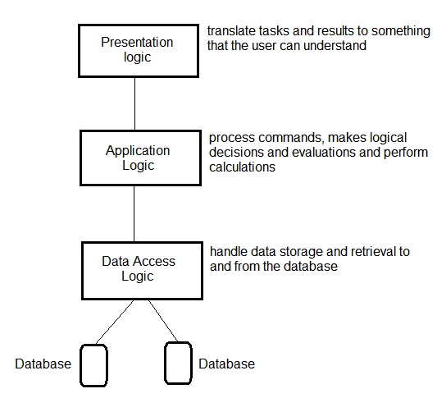

**Figure 2**: 3-tier client-server architecture

**UML Diagrams**

During the development of SMT application we have used following diagrams for understanding the requirements and control structure of the system.

1. Use case diagram
2. Class Diagram
3. Sequence Diagram

**Use case diagram**

The use case diagram helped to understand the functional requirements of the SMT without worrying about how those requirements will be implemented. It shows the interaction between the system and the user in the particular environment. The use case model contains actors and the use cases. The actors are the external entities and the use cases are the functions of the system.

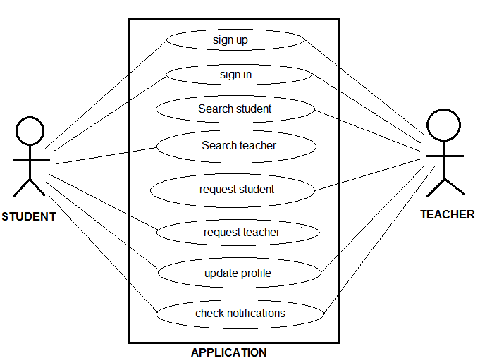

**Figure 3:** Use case diagram of SMT

The above figure depicts the major functions of the SMT application. There are two major actors- Student and Teacher. The student can perform functions like sign up, sign in, search teacher, request teacher, update profile and check notification. The teacher also perform the same functions except it

searches for a student. The system requirements specify that the entity cannot search for the same entity group.

**Class diagram**

A class diagram shows the static structure of an object-oriented model: the object classes, their internal structure and the relationship in which they participate. In UML, a class is represented by a rectangle with three compartments separated by horizontal lines. The class name in the top compartment, list of attributes in the middle and list of operations in the bottom compartment.

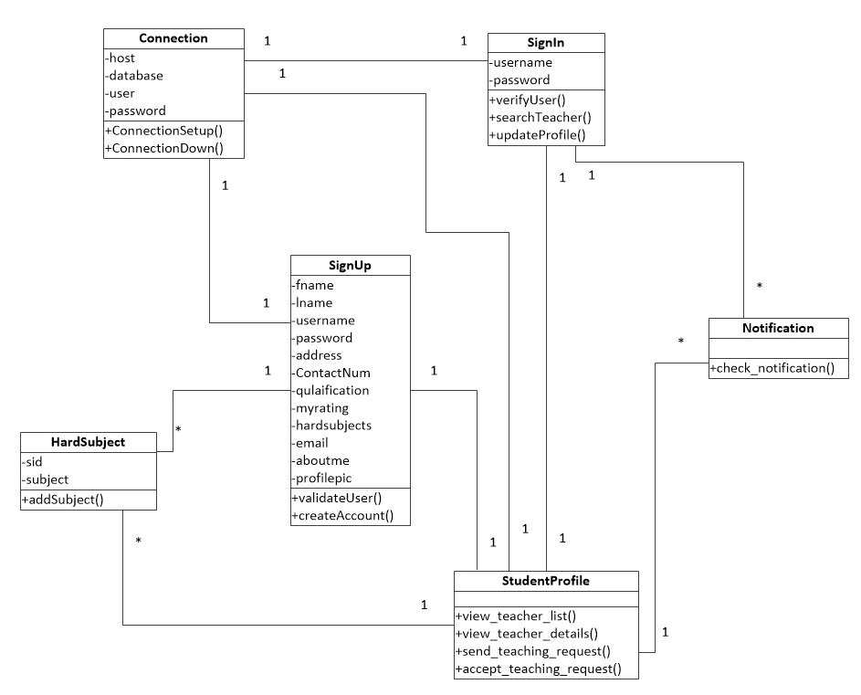

**Figure 4:** Class diagram of Student

The above figure represents the objects that are related to perform all the activities of the student entity. There are 6 major classes that work in coordination to complete the requirements related to the student entity.

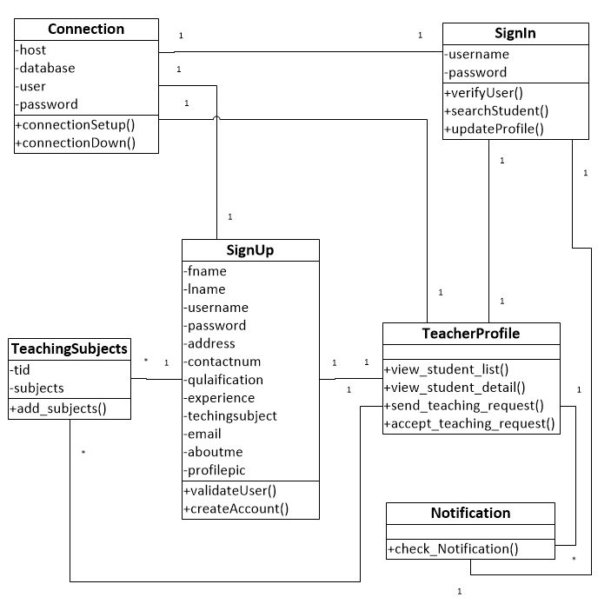

**Figure 5:** Class diagram of Teacher

The class diagram of teacher is also similar to that of the student instead it performs the teacher related operations. It also contains 6 major classes for the implementation of the teacher activities.

**Sequence diagram**

A sequence diagram depicts the interactions among objects during a certain period of time. Because the pattern of interactions varies from one use case to another, each sequence diagram shows only the interactions pertinent to a specific use case.

(**Figure 6**: sequence diagram of student)

The above figure represents the sequence diagram of student. The student activity is initiated when the student invokes the connectionSetup() in the connection object. The objects interact with each other by passing appropriate messages. The connection object is activated till the time where student ends its session.

(**Figure 7**: sequence diagram of teacher)

The teacher sequence diagram is analogous to the student sequence diagram. The teacher is activated till the end of its session. All the activities of teacher are performed by communicating appropriate messages between the objects.

**Database Design**

**ER diagram**

The er-diagram represents the real world objects called entities and association among those entities. The er-diagram is the best tool to design the database. It helps the designer to determine the useful entities of the database, the relationship they holds and the degree of relationship.

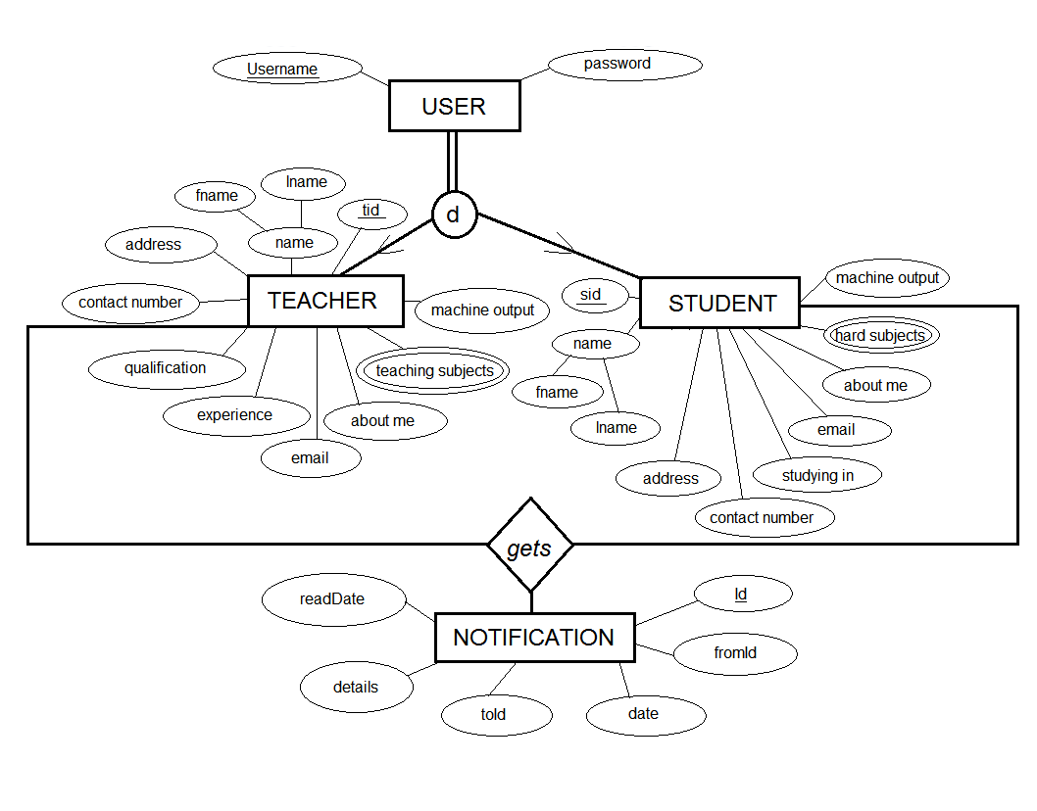

**Figure 8:** ER diagram of SMT application

We have designed the database by using the specialization concept. The USER is the superclass, TEACHER and STUDENT are the subclass of the USER. The class subclass relationship is disjoint. The NOTIFICATION entity type stores the notification that has been sent to teacher entity and student entity.

**Schema diagram**

The er-diagram is mapped to schema diagram for creating relations in the database. Each rectangle in the schema diagram corresponds to an actual relational table.

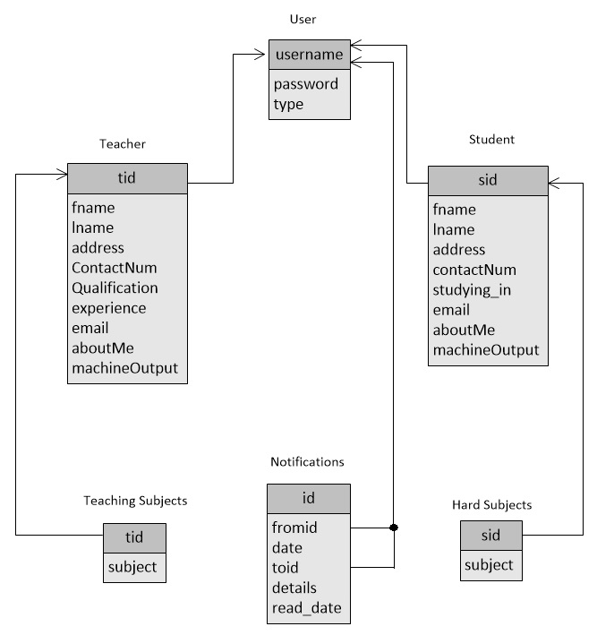

**Figure 9**: Schema diagram of SMT application

In the above figure the attributes in the top compartment represents the primary key for that relation. The relation name is specified at the top of each rectangle. The remaining bottom compartment of the rectangle represents the component attributes of the relation. The arrow from A to B represents A is a foreign key referencing B.

**Back Propagation Design**

The SMT uses ANN-BP algorithm. The BP algorithm is a supervised learning. The neural network contains three layers in most cases, or sometimes four. They have one Input Layer, one or more Hidden Layer and one Output Layer. The design of the ANN-BP algorithm for SMT is shown below:

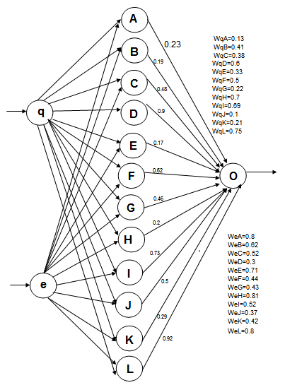

**Figure 10:** Neural Network of SMT before training

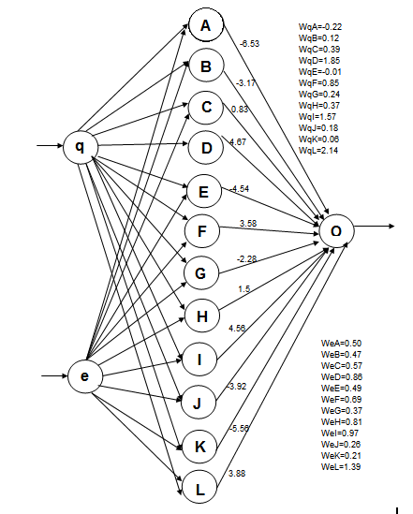

**Figure 11:** Neural Network of SMT after training

We have selected only one hidden layer. The BP algorithm uses sigmoid function since it is differentiable. The number of nodes in the hidden layer is selected to decrease the error component generated by the difference between actual output and desired output. The algorithm is explained in the system implementation.

**IMPLEMENTATION**

The SMT application is a web based application developed in PHP and My SQL at backend and HTML, css and JavaScript at frontend. The application was built in a 1 tier environment utilizing the same resources of the desktop for presentation logic, application logic and DBMS. The real implementation of the SMT application supports 3 tier architecture.

**Development of SMT application**

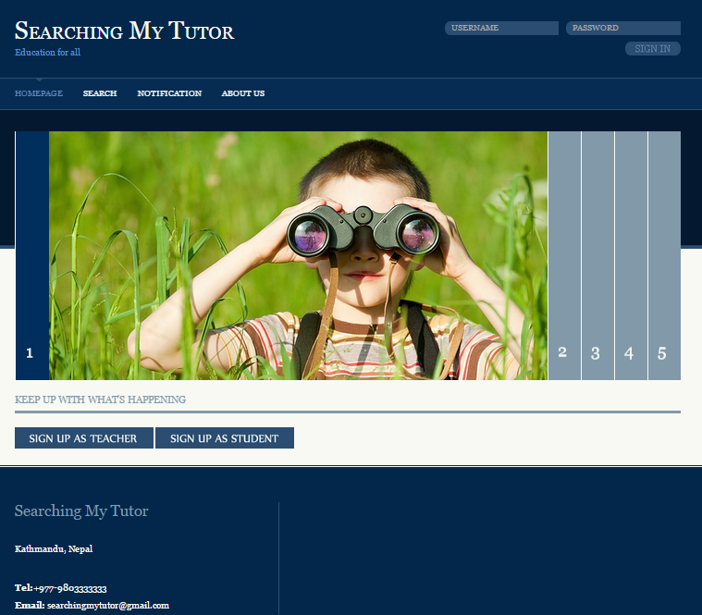

Figure ***(number)*** : Homepage of SMT

***I am impressed with this picture :-) him/her who has given this concept, say thanks from my side***

The homepage of SMT provides sign in option, sign up option for teacher and student, and several navigation options. The user must be authenticated to view other sections of the application except ‘About us’ section. The simplicity in the UI is useful for the new users to use the system easily without any confusion.

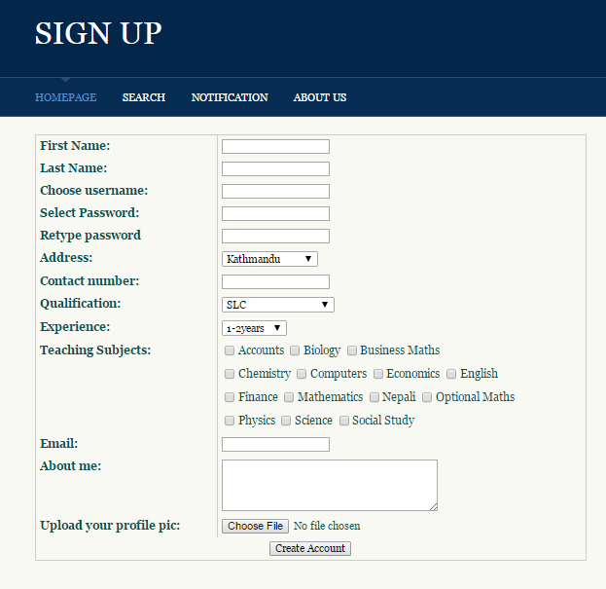

Figure: Teacher sign up form

The teacher needs to sign up before viewing the search results.

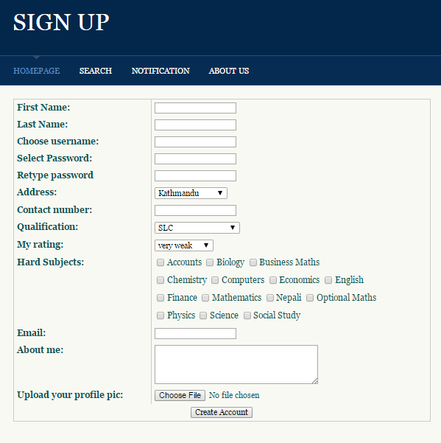

Figure: Student sign up form

The student also needs to sign up before searching the teachers.

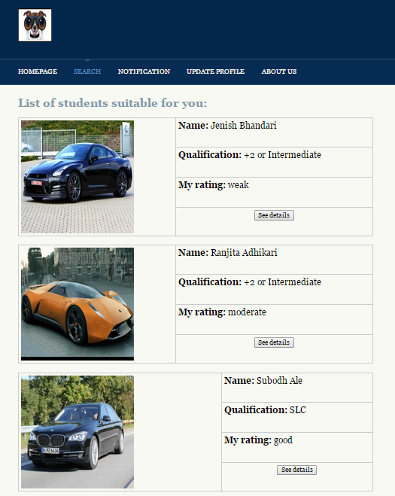

Figure: Search result for a teacher user

When a teacher searches for a student the results are displayed as shown in above figure. The results are displayed as soon as the teacher signs in or signs up.

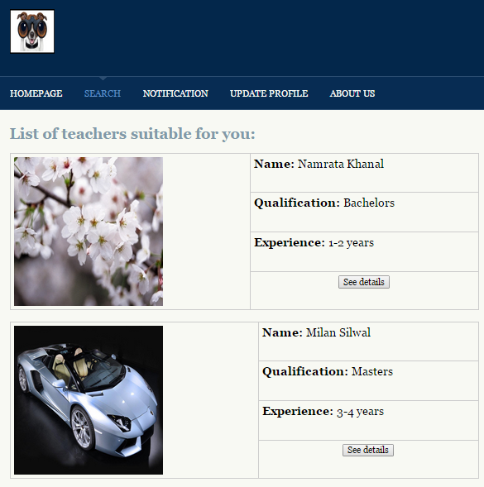

Figure: Search result for student user

The list of teachers is shown to the student user when it signs in or signs up.

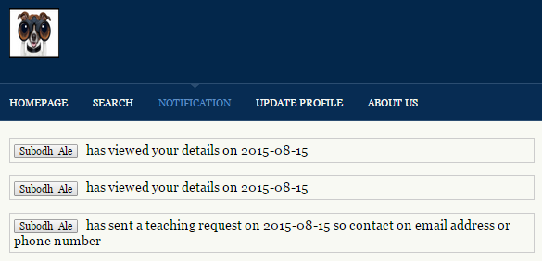

Figure: Notifications of user: Teacher

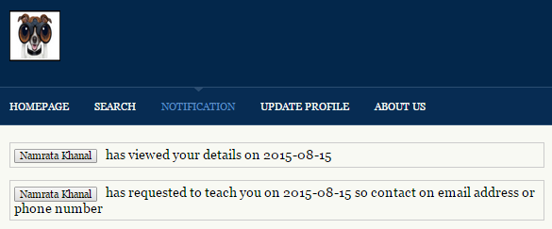

Figure: Notifications of user: Student

Both the users are notified with who has seen their details and who has applied to/for teaching.

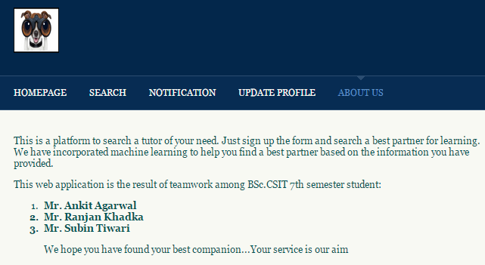

Figure: About us page

The about us page simply display the information about who has developed the SMT application.

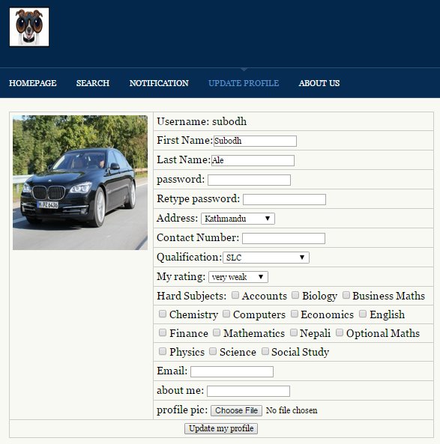

Figure: Update of Student user

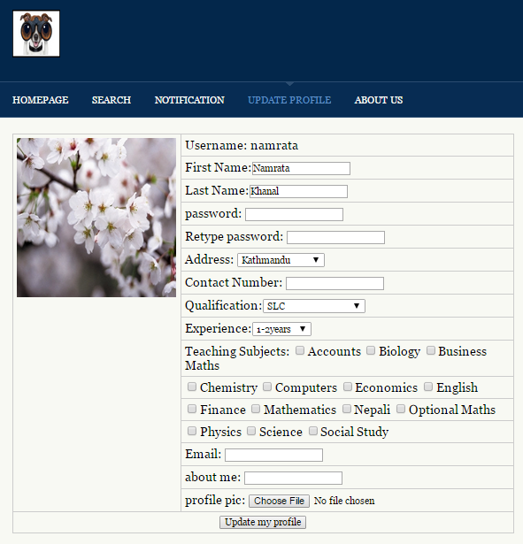

Figure: Update of Teacher user

Both the users are facilitated with the update interface to update their details. The detail update is very important to help SMT application for searching correct and accurate data.

**Implementation of BP Algorithm**

***(It is better if you write the algoroithm too)***

The BP algorithm is a supervised learning algorithm. So we had trained the neural network with sample data. The train…….. The algorithm uses qualification and experience attribute of the teacher and qualification and study level of student. The input to the algorithm is represented by numerical values as shown below:

Table 1: Input values of BP algorithm

|  |  |  |  |
| --- | --- | --- | --- |
| User | qualification | experience | Study level(my rating) |
| Teacher | SLC (0.1)  +2 or intermediate (0.3)  Bachelor (0.5)  Master (0.7)  Master+ (0.9) | 1-2 years (0.15)  3-4 years (0.3)  5-6 years (0.45)  7-8 years (0.6)  9+ years (0.75) |  |
| Student | SLC (0.1)  +2 or intermediate (0.3)  Bachelor (0.5)  Master (0.7)  Master+ (0.9) |  | very weak (0.15)  weak (0.3)  moderate (0.45)  good (0.6)  fast learner (0.75) |

***(please it is better if you can give some references or some logical reason that how you assign these weights)***

Here, each value of the attribute is represented numerically like for attribute ‘qualification’ the value SLC is represented with 0.1 and so on. The teacher and student user has same first input of qualification but the second input is different. The teacher has experience as second input to ANN and student has study level also referred to as my rating in SMT application. The experience represent the experience as a tuition teacher.

Now we have two input nodes in hidden layer q and e as shown in figure 10 and figure 11. The hidden layer contains 12 nodes for processing. The output layer contains only one node since we are interested only in getting a matrix value for prioritizing and searching purpose. The matrix value is generated within the range of [0, 1]. Higher the value more superior the user is.

Example: If there are two teachers with matrix value 0.4 and 0.68 then the teacher with matrix value is more superior than the teacher with matrix value 0.4. Similar interpretation applies for student.

The desired output for all the possible combination of the inputs is as follows:

Table 2: Inputs and desired outputs

|  |  |  |  |  |  |
| --- | --- | --- | --- | --- | --- |
| q | e | output | q | e | output |
| SLC | 1-2 years | 0.04 | Bachelor | 7-8 years | 0.56 |
| SLC | 3-4 years | 0.08 | Bachelor | 9+ years | 0.6 |
| SLC | 5-6 years | 0.12 | Master | 1-2 years | 0.64 |
| SLC | 7-8 years | 0.16 | Master | 3-4 years | 0.68 |
| SLC | 9+ years | 0.2 | Master | 5-6 years | 0.72 |
| +2 or intermediate | 1-2 years | 0.24 | Master | 7-8 years | 0.76 |
| +2 or intermediate | 3-4 years | 0.28 | Master | 9+ years | 0.8 |
| +2 or intermediate | 5-6 years | 0.32 | Master+ | 1-2 years | 0.84 |
| +2 or intermediate | 7-8 years | 0.36 | Master+ | 3-4 years | 0.88 |
| +2 or intermediate | 9+ years | 0.4 | Master+ | 5-6 years | 0.92 |
| Bachelor | 1-2 years | 0.44 | Master+ | 7-8 years | 0.96 |
| Bachelor | 3-4 years | 0.48 | Master+ | 9+ years | 0.99 |
| Bachelor | 5-6 years | 0.52 |  | | |

**TESTING**

The testing phase is done to verify and validate the SMT application. The SMT application is tested to check if the developed system is free from programming and logical errors, and the developed application is what we were expecting. It also checks whether all the system and user requirements are met or not. We have conducted following tests.

(specify some testing types)

**Maintenance and Support**

**Conclusion and Enhancements**